Design Patterns
Package java/org/jabref/logic

1. java/org/jabref/logic/bst/PurifyFunction.java
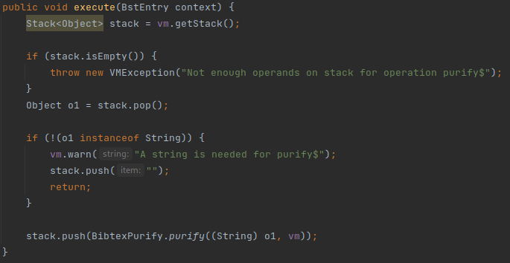

Identified Pattern: Proxy
Rationale: This class does error checking but the actual work is done by the BibtexPurify class. This class acts as a protection proxy.

Note: This pattern can also be found in many classes inside the logic/bst package.

2. java/org/jabref/logic/citationstyle/CitationStyleGenerator.java
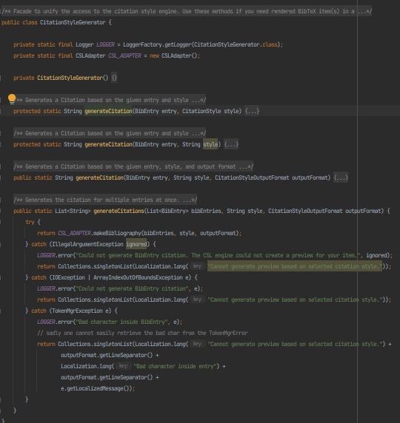
Identified Pattern: Proxy
Rationale: Unlike what is said in the first comment (lines 14-17) this looks more like a protection proxy pattern. A facade would be an interface that provides access to basic actions by making complicated calls. This class only provides the user with a proxy to the CLS_ADAPTER, and protects him/her from un-catched exceptions.

3. java/org/jabref/logic/logging/LogMessages.java
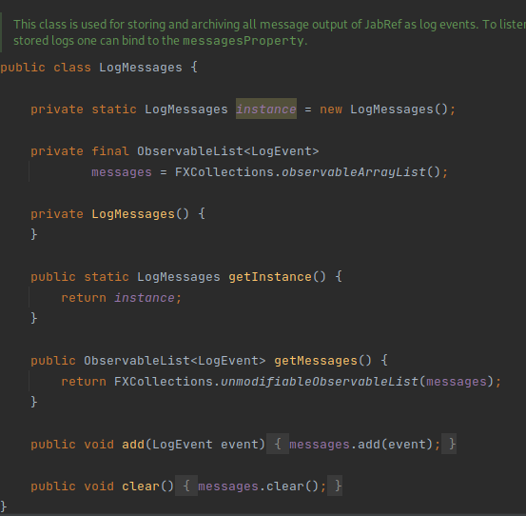
Identified Pattern: Singleton
Rationale: This class acts as a single acess point for the “GUI Error Console”’s error messages appended by the GUIAppender. Since there can be many “GUI Error Console” windows being shown at the same time we want the same output to be showing in the various instances.

